**Aarambh Classes**

**Class IX**

**Physics worksheet**

**Motion**

1**.** The graph in below figure shows the positions of a body at different times. Calculate the

speed of the body as it moves from (i) A to B (ii) B to C and (iii) C to D

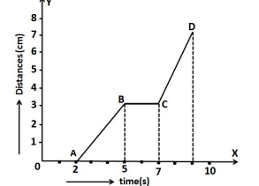

2.**.** The velocity time graph of an ascending passenger lift is given below. What is the

acceleration of the lift: (i) during the first two seconds (ii) between 2nd and 10th second (iii)

During the last two seconds.

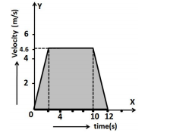

3. A body is moving uniformly with a velocity of 5m/s. Find graphically the distance travelled

by it in 5 seconds.

4. Study the speed-time graph of a body shown in below figure and answer the following

questions:

(a) What type of motion is represented by OA?

(b) What type of motion is represented by AB?

(c) What type of motion is represented by BC?

(d) Calculate the acceleration of the body.

(e) Calculate the retardation of the body.

(f) Calculate the distance travelled by the body from A to B.

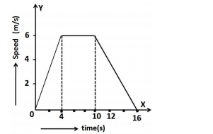

5. In the above question, calculate (i) distance travelled from O to A (ii) distance travelled

from B to C. (iii) total distance travelled by the body in 16 sec

6. A car is moving on a straight road with uniform acceleration. The following table gives the

speed of the car at various instants of time:

|  |  |  |  |  |  |  |
| --- | --- | --- | --- | --- | --- | --- |
| Time (s) | 0 | 10 | 20 | 30 | 40 | 50 |
| Speed (m/s) | 5 | 10 | 15 | 20 | 25 | 30 |

Draw the speed time graph choosing a convenient scale. Determine from it (i) the

acceleration of the car (ii) the distance travelled by the car in 50 sec .

7. The graph in below figure shows the positions of a body at different times. Calculate the

speed of the body as it moves from (i) A to B (ii) B to C and (iii) C to D.

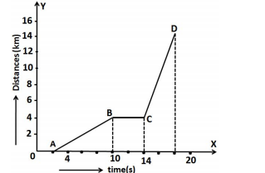

8. A car is moving on a straight road with uniform acceleration. The speed of the car varies

with time as follows:

|  |  |  |  |  |  |  |
| --- | --- | --- | --- | --- | --- | --- |
| Time (s) | 0 | 2 | 4 | 6 | 8 | 10 |
| Speed (m/s) | 4 | 8 | 12 | 16 | 20 | 24 |

Draw the speed time graph choosing a convenient scale. Determine from it (i) the

acceleration of the car (ii) the distance travelled by the car in 10 sec.

**9.** The graph given below is the velocity-time graph for a moving body. Find (i) velocity of

the body at point C (ii) acceleration acting on the body between A and B (iii) acceleration

acting on the body between B and C .

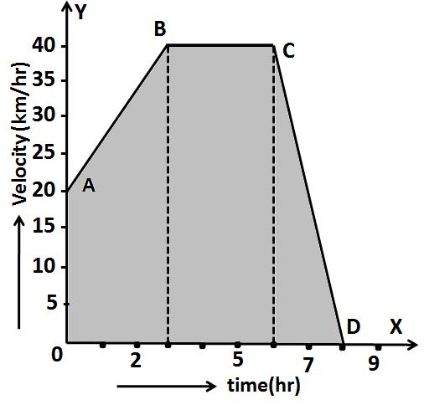

10. A car increases its speed from 20 km/h to 50 km/h in 10 seconds. What is its

acceleration?

**11.** A ship is moving at a speed of 56km/h. One second later, it is moving at 58km/h.

What is its acceleration?

**12.** A scooter acquires a velocity of 36km/h in 10 seconds just after the start. Calculate

the acceleration of the scoter.

**13.** A racing car has uniform acceleration of 4m/s2 . What distance will it cover in 10

seconds after start?

**14.** A car acquires a velocity of 72km/h in 10 seconds starting from rest. Find (a) the

acceleration (b) the average velocity (c) the distance travelled in this time.

**15 .** A body is accelerating at a constant rate of 10m/s2 . If the body starts from rest, how

much distance will it cover in 2 seconds?

16. An object undergoes an acceleration of 8m/s2 starting from rest. Find the distance

travelled in 1 second.

17 .A moving train is brought to rest within 20 seconds by applying brakes. Find the

initial velocity, if the retardation due to brakes is 2m/s2.

**18.** A car accelerates uniformly from 18km/h to 36 km/h in 5 seconds. Calculate (i)

acceleration and (ii) the distance covered by the car in that time.

**19.**A body starts to slide over a horizontal surface with an initial velocity of 0.5 m/s.

Due to friction, its velocity decreases at the rate of 0.05 m/s2 . How much time will it

take for the body to stop?

**20.**A train starting from the rest moves with a uniform acceleration of 0.2 m/s2 for 5

minutes. Calculate the speed acquired and the distance travelled in this time.

**21.**A bus was moving with a speed of 54 km/h. On applying brakes, it stopped in 8

seconds. Calculate the acceleration and the distance travelled before stopping.

**22.**A motor cycle moving with a speed of 5 m/s is subjected to an acceleration of 0.2

m/s2 . Calculate the speed of the motor cycle after 10 seconds and the distance

travelled in this time.

**23.**The brakes applied to a car produce an acceleration of 6 m/s2 in the opposite

direction to the motion. If the car takes 2 seconds to stop after the application of

brakes, calculate the distance it travels during this time.

**24.**A train starting from rest attains a velocity of 72 km/h in 5 minutes. Assuming that

the acceleration is uniform, find (i) the acceleration and (ii) the distance travelled by

the train for attaining this velocity.

**25.**Calculate the speed of the tip of second’s hand of a watch of length 1.5 cm.

**26.**A cyclist goes once round a circular track of diameter 105m in 5 minutes. Calculate

his speed.

**27 .**A cyclist moving on a circular track of radius 50m complete revolution in 4 minutes.

What is his (i) average speed (ii) average velocity in one full revolution?

**28.**The length of minutes hand of a clock in 5 cm. Calculate its speed.

**29.**A car starts from rest and moves along the x-axis with constant acceleration 5m/s2

for 8 seconds. If it then continues with constant velocity, what distance will the car

cover in 12 seconds since it started from the rest?

**30.**An object is dropped from rest at a height of 150m and simultaneously another

object is dropped from rest at a height 100m. What is the difference in their heights

after 2 seconds if both the objects drop with same acceleration? How does the

difference in heights vary with time?